if we want to skip any testcase from project give this command

--> mvn test -Dtest=!testcaseName (Syntax)

--> mvn test -Dtest=!testcase1 (Reality) (To skip that paticular testcase)

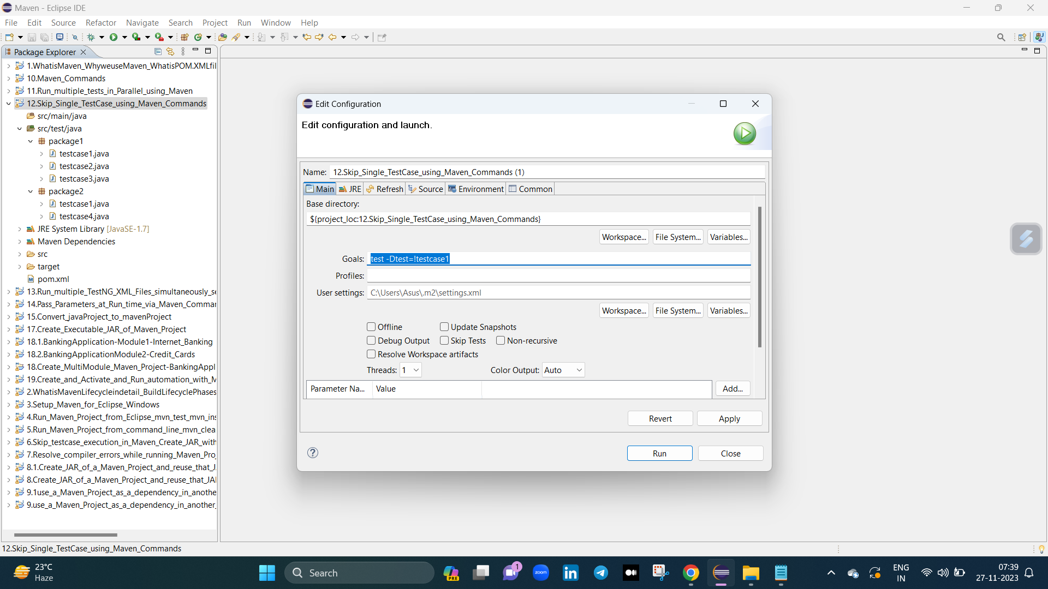

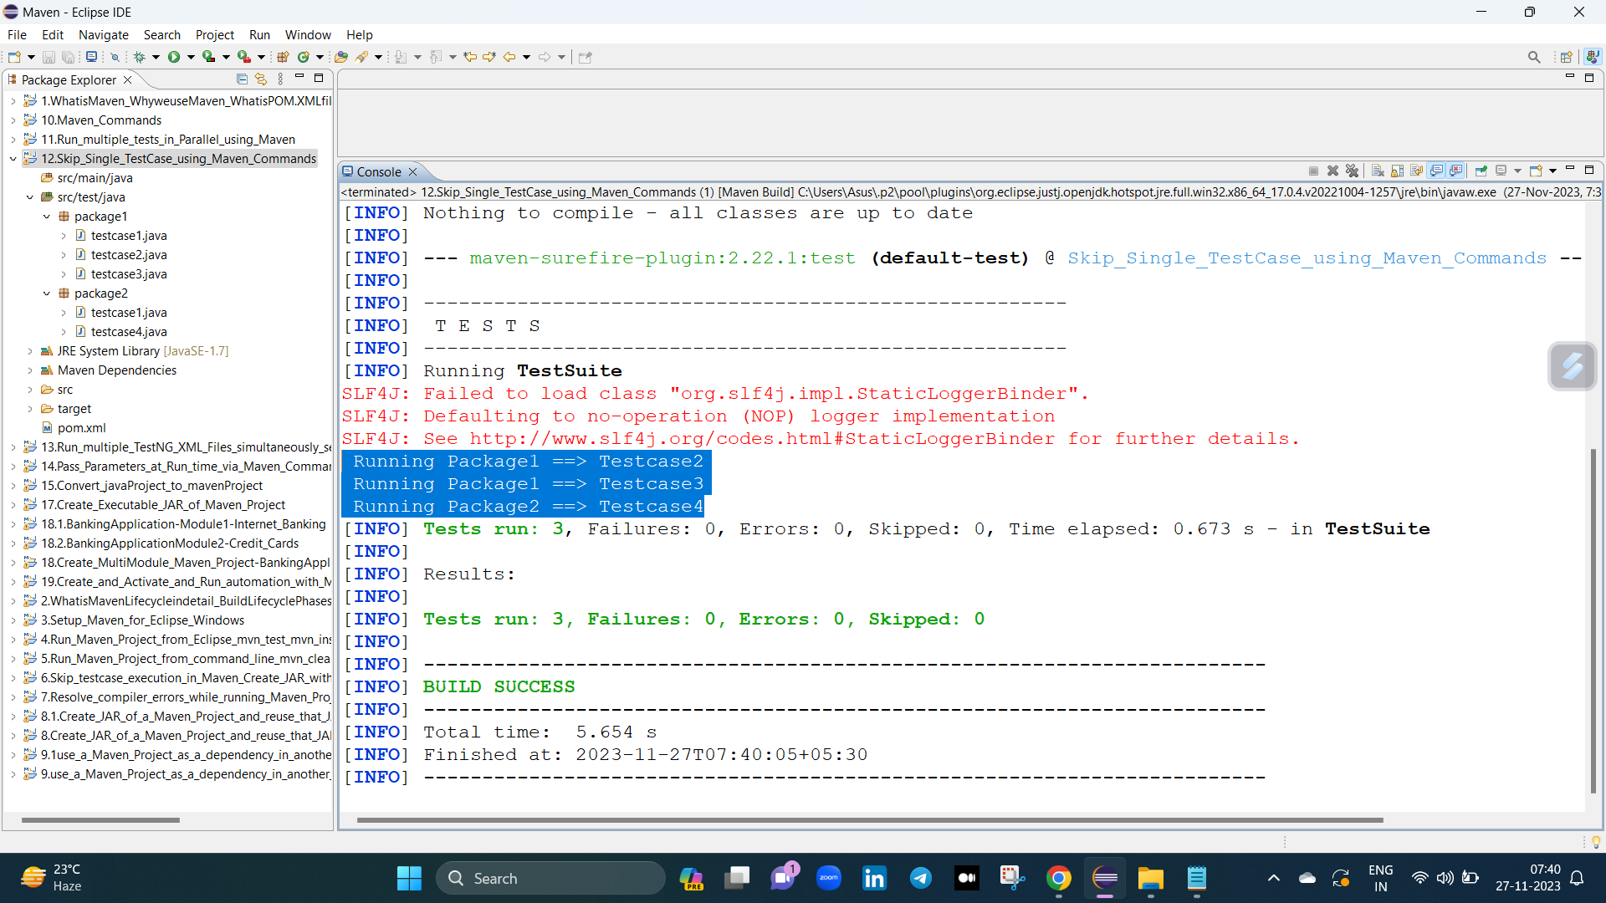

if we want to skip any testcase from particular package give this command

--> mvn test -Dtest=!packageName.testcaseName (Syntax)

--> mvn test -Dtest=!package1.testcase1 (Reality) (To skip that paticular testcase from particular package)

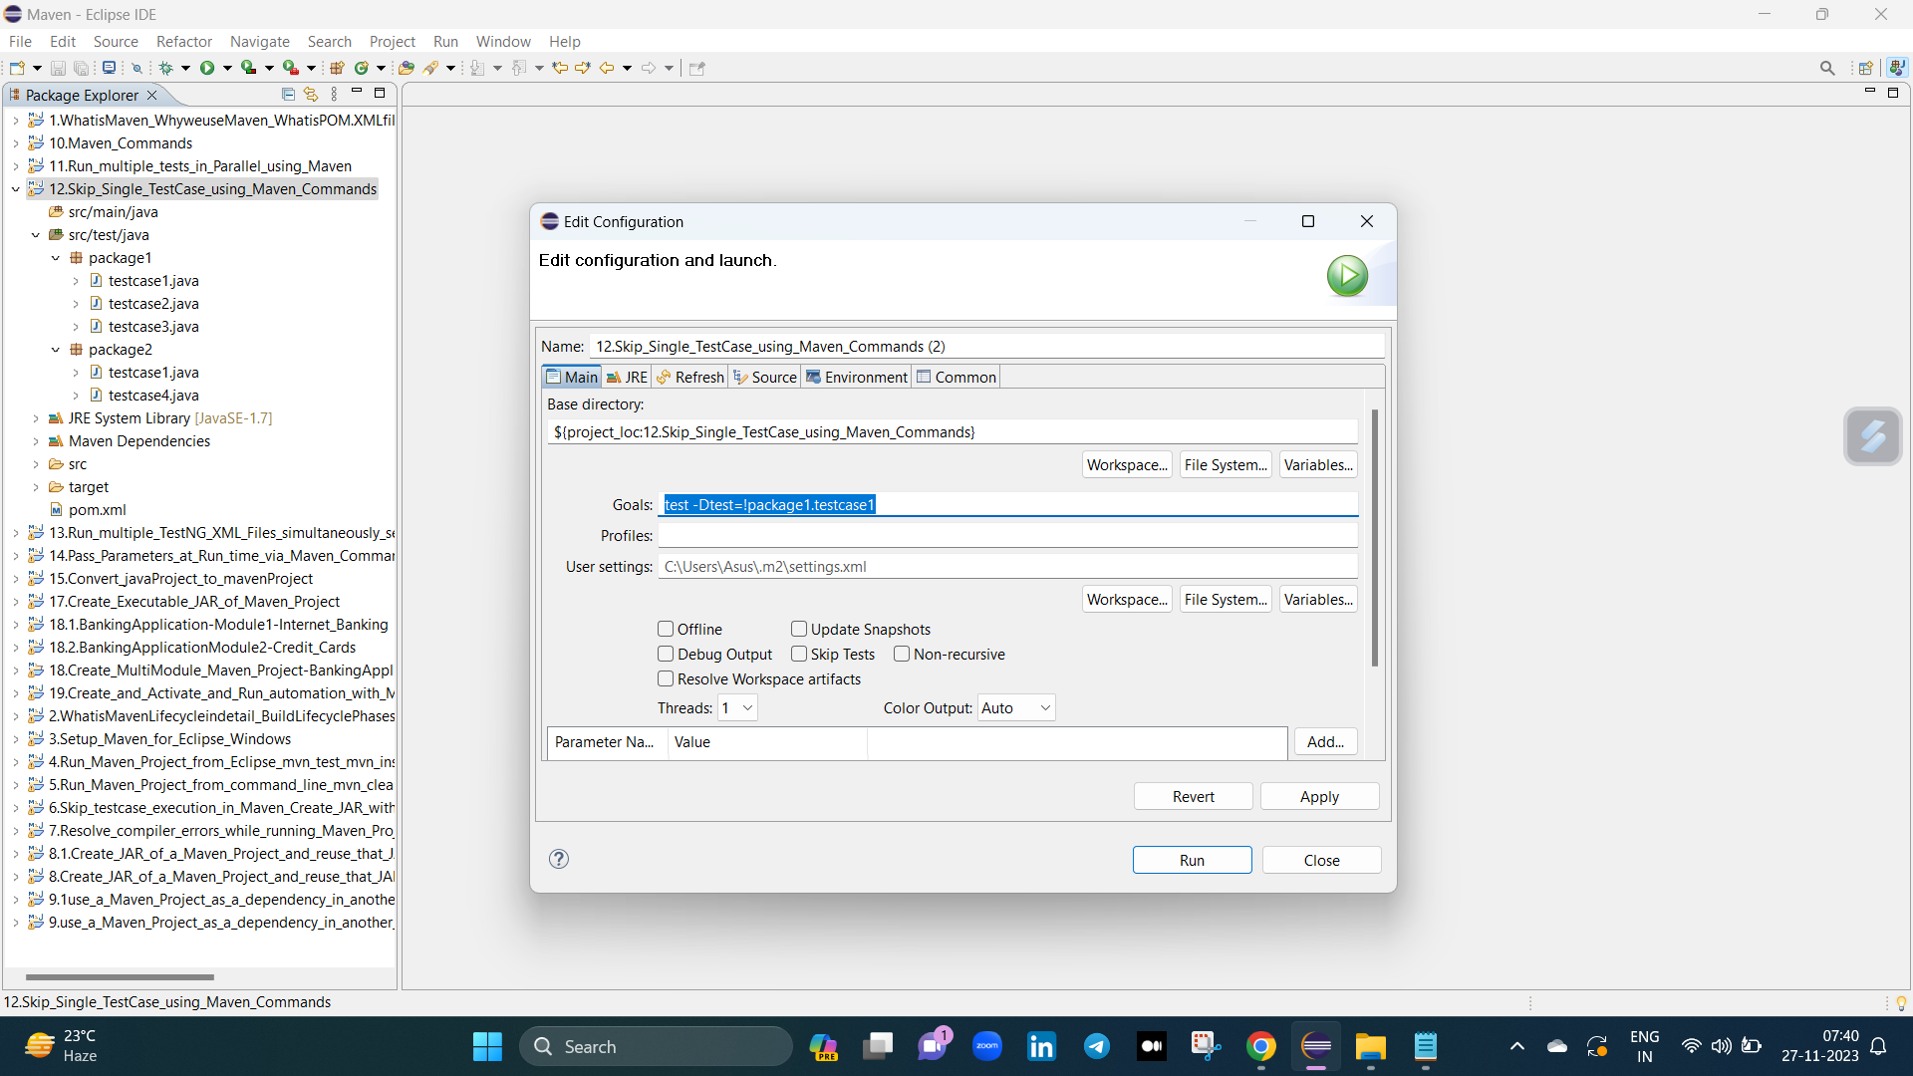

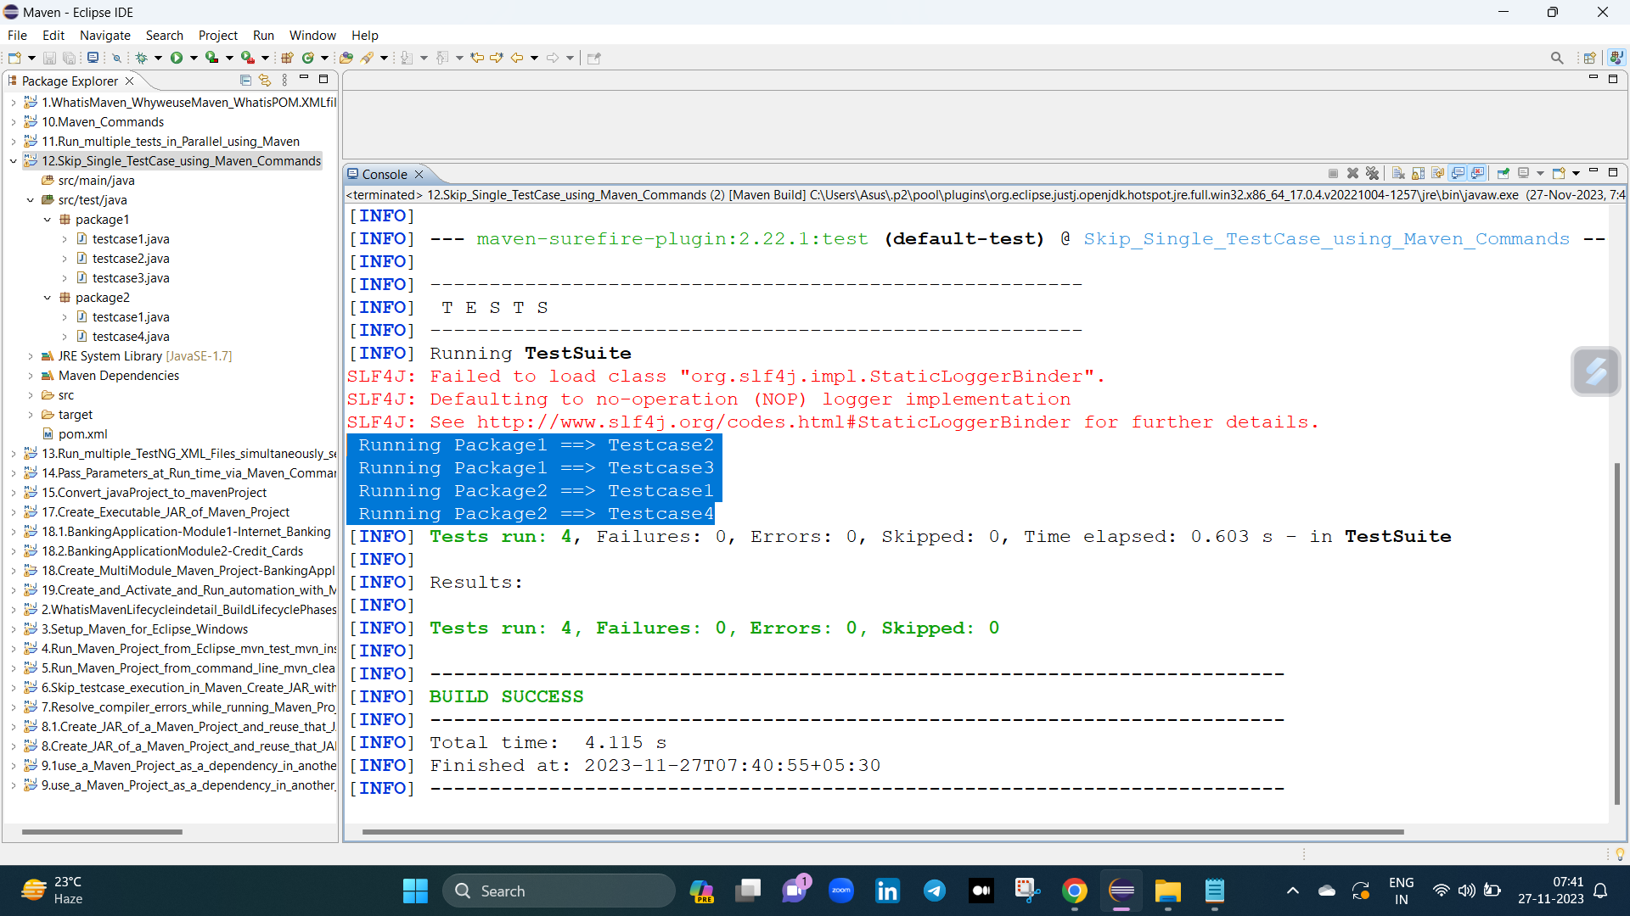

if we want to skip multiple testcase at a time give this command

--> mvn test -Dtest=!testcaseNameX,!testcaseNameY (Syntax)

--> mvn test -Dtest=!testcase1,!testcase3 (Reality) (To skip that multiple testcases)

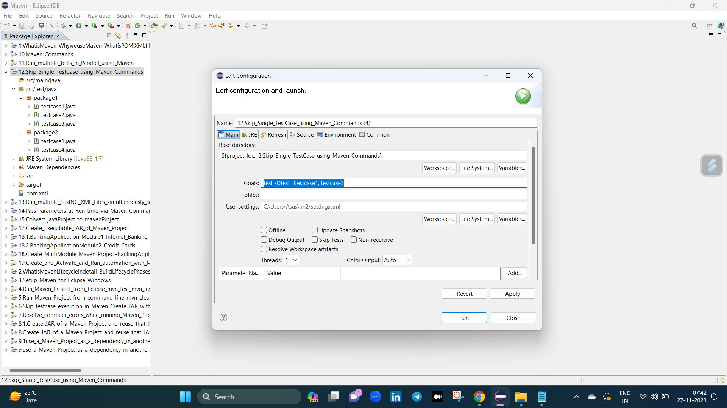

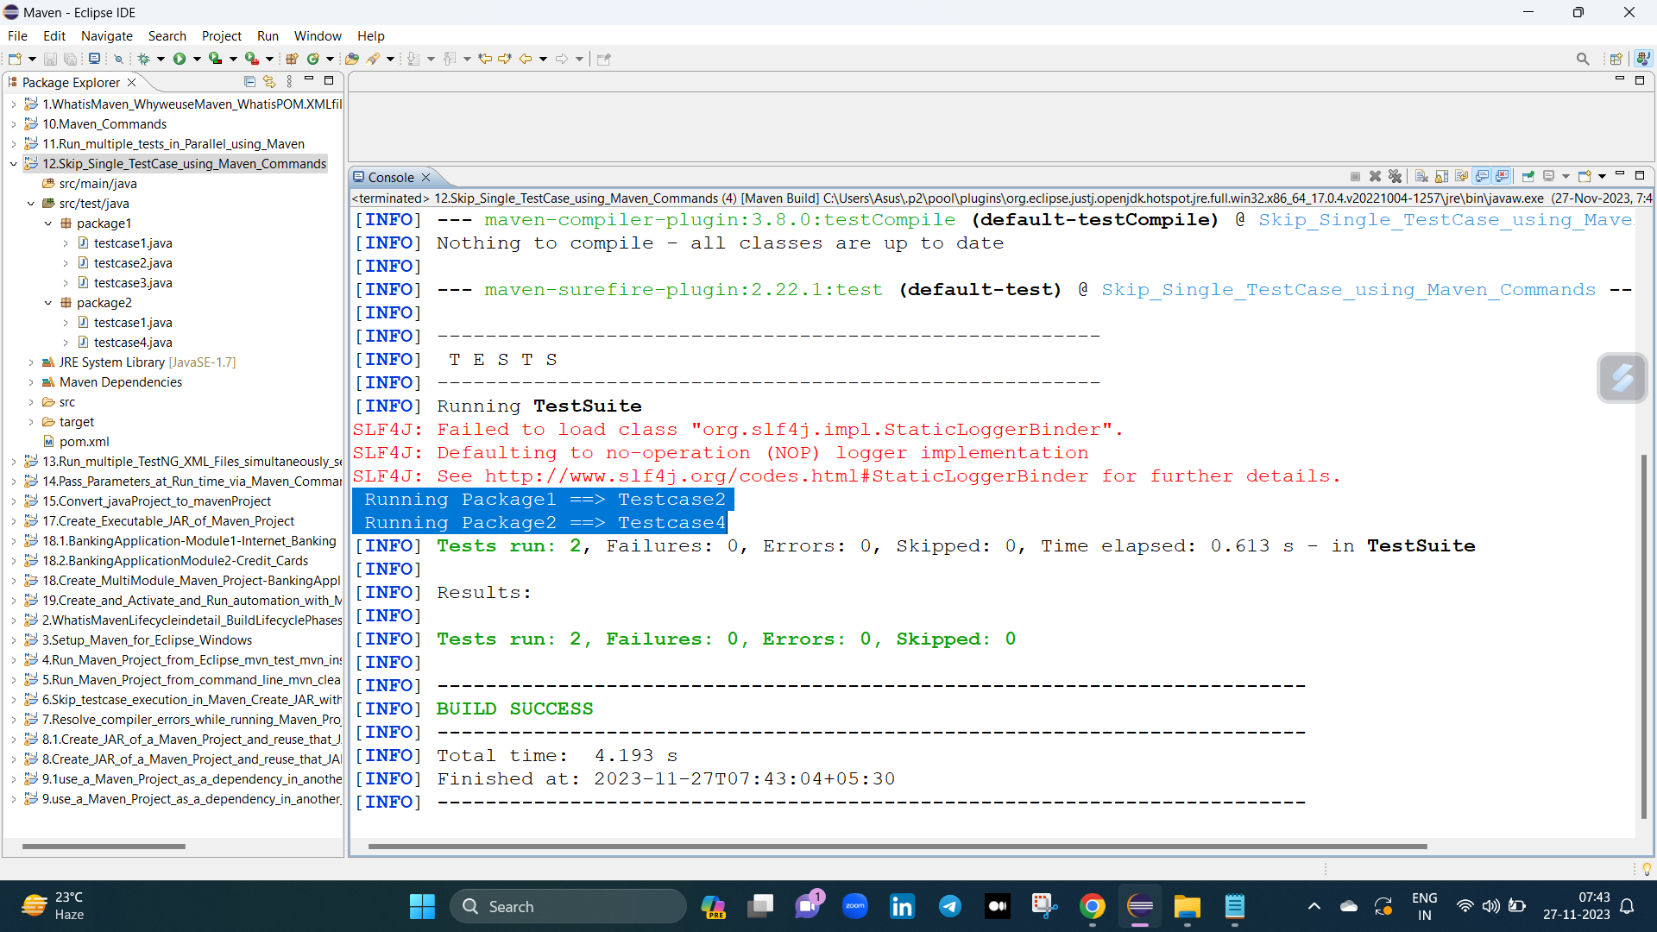

===========================================================================================================

elagea same cmd nunchi run chaiyali antea evea commands cmd lo estea saripotundi

if we want to skip any testcase from project give this command

--> mvn test -Dtest=!testcaseName (Syntax)

--> mvn test -Dtest=!testcase1 (Reality) (To skip that paticular testcase)

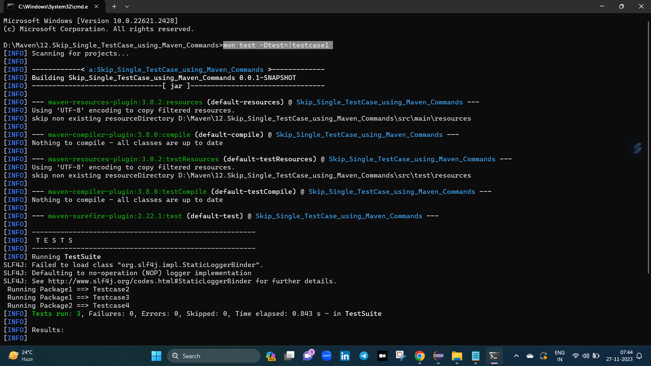

if we want to skip any testcase from particular package give this command

--> mvn test -Dtest=!packageName.testcaseName (Syntax)

--> mvn test -Dtest=!package1.testcase1 (Reality) (To skip that paticular testcase from particular package)

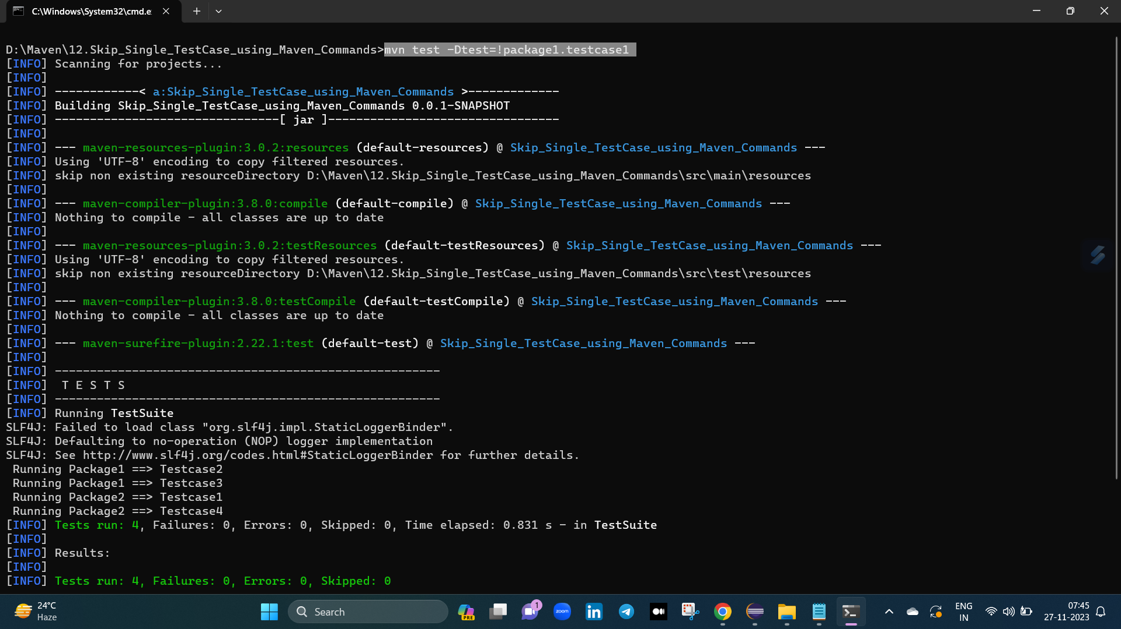

if we want to skip multiple testcase at a time give this command

--> mvn test -Dtest=!testcaseNameX,!testcaseNameY (Syntax)

--> mvn test -Dtest=!testcase1,!testcase3 (Reality) (To skip that multiple testcases)

